Explanation of Mahjong Competition Rules
(Some Discussional Words)
Mahjong Competition Rules is issued by World Mahjong Organization. The tenet is to advocate a healthy, scientific and friendly Mahjong culture, to promote friendship and cultural exchange among different countries and regions, and to host civilized, normative and exquisite Mahjong competitions.
It will be briefly explained as the following five aspects.
Item 1 Principle for Counting the Basic Points
(1) After declaring “Hu” or “Hu Pai”, the player identifies the primary fan, which has the highest points generally. Then add the points of the other different fans.
Points of the inevitable fans included by the primary fan can not be added. There are some examples as follows.
1、The following fans include “No Honors” inevitably: Nine Gates, Seven Shifted Pairs, All Terminals, Full Flush, Upper Tiles, Lower Tiles, Upper Four, Lower Four, All Chows, All Simples etc.
Middle Tiles, All Even Pungs and All Fives include All Simples inevitably, and All Simples includes No Honors inevitably.
Pure Terminal Chows and Three-Suited Terminal Chows include All Chows (All Chows include No Honors also), Two Terminal Chows and Mixed Double Chow.
2、The following fans include “Single Wait” inevitably: Four Kongs, Seven Shifted Pairs, Seven Pairs, Melded Hand etc. Thirteen Orphans sometimes wait for thirteen tiles, so Single Wait can not be added either.
3、The following fans include “Self-Drawn” inevitably: Out with Replacement Tile, Last Tile Draw, Fully Concealed Hand etc.
4、The following fans include “Tile Hog” inevitably: Quadruple Chow and all the Kong related fans.
5、The following fans include “Concealed Hand” inevitably: Nine Gates, Seven Shifted Pairs, Four Concealed Pungs, Seven Pairs, Fully Concealed Hand, Thirteen Orphans, Greater Honors and Knitted Tiles, Lesser Honors and Knitted Tiles etc.
Nine Gates and Seven Shifted Pairs include Full Flush.
Thirteen Orphans, Greater Honors and Knitted Tiles, and Lesser Honors and Knitted Tiles include All Types.
6、The following fans include “Outside Hand” inevitably: All Honors, All Terminals, All Terminals and Honors etc.
7、The following fans include “All Pungs” inevitably: Big Four Winds, Four Pure Shifted Pungs, All Even Pungs etc.
8、Some other examples:
Quadruple Chow include Pure Triple Chow and Pure Double Chow inevitably.
Four Concealed Pungs include Three Concealed Pungs and Two Concealed Pungs inevitably.
Big Three Dragons include Two Dragons Pungs and Dragon Pung inevitably.
Big Four Winds include Big Three Winds, Prevalent Wind, Seat Wind and Pung of Terminals or Honors inevitably.
Special Explanation: There is a special rule about Tile Hog. If a fan has only six patterns, Tile Hog can not be added when Seven Pairs appears. Because Seven Pairs with six patterns inevitably include Tile Hog. For example,
All Green only has six patterns as Green Dragon, 2 Bam,3 Bam,4 Bam,6 Bam and8 Bam.
All Terminals only has six patterns as 1Bam, 9Bam, 1Dot, 9Dot, 1Character and 9 Character.
(2) Adding the points of the other different fans, the player should follow the five principles.
Prin. 1 The Non-Repeat Principle
Ex. 1：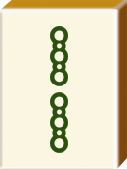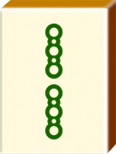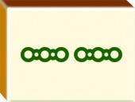 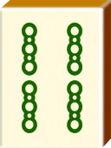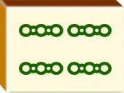 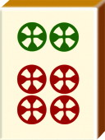 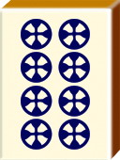 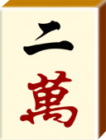
All Even Pungs includes All Pungs and All Simples inevitably, so points of the latter two fans can not be added.
Ex.2：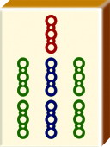 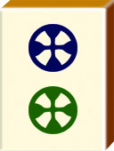 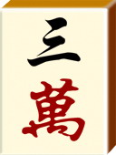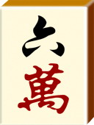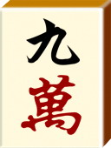 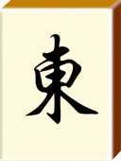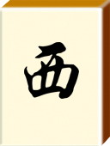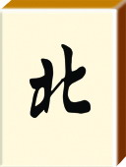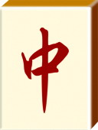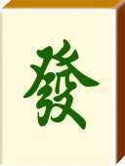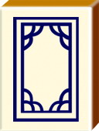
Lesser Honors and Knitted Tiles include All Types and Concealed Hand inevitably, so points of the latter two fans can not be added.
Ex.3：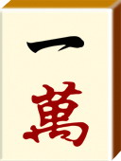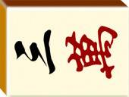 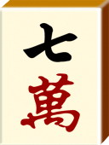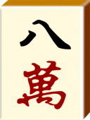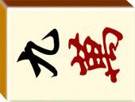 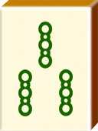 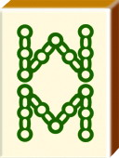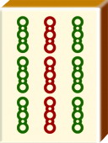 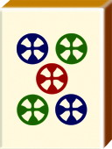
Three-Suited Terminal Chows include All Chows, No Honors, Two Terminal Chows and Mixed Double Chow, so points of the latter four fans can not be added.
Prin.2 The Non-Separation Principle
Ex.1：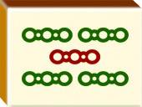 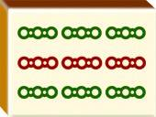
In this example, Half Flush as the primary fan can not be divided and rearranged as Seven Pairs.
Ex.2：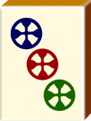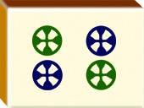 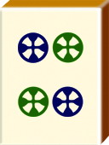
In this example, Pure Triple Chow as the primary fan can not be divided and rearranged as Pure Shifted Pungs and All Pungs.
Ex.3 ： 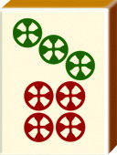
In this example, Seven Shifted Pairs as the primary fan can not be divided and rearranged as Concealed Hand, All Chows, All Simples and Short Straight combined.
Prin.3 The Non-Identical Principle
Ex.1：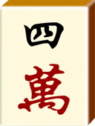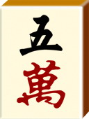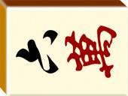 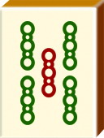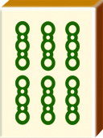 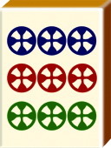
Once Characters of 456, Bams of 567, and Dots of 678 are identified as Mixed Shifted Chows, Characters of 456 and Bams of 567 can not combine with Dots of 345 to be identified as another added Mixed Shifted Chows. Only Short Straight can be added.
Ex.2： 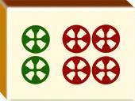
Once Bams of 444, Characters of 555 and Dots of 666 are identified Mixed Shifted Pungs, Characters of 555 and Dots of 666 can not combine with Bams of 777 to be identified as another added Mixed Shifted Pungs.
Ex.3：
Once Pure Straight is identified as the primary fan, Characters of 456, 789 can not combine with another Characters of 123 to be identified as another added Pure Straight.
Prin.4 Freedom to Choose the Highest Points
Ex.1：
Concealed Hand and Self-Drawn have 3 points, and Fully Concealed Hand has 4 points. When Concealed Hand and Self-Drawn appear together, it is better to count the points of Fully Concealed Hand.
It is better to count the points of All Simples not No Honors.
Ex.2：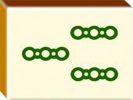
Robbing The Kong has 8 points, and Last Tile has 4 points. So it is better to count the points of Robbing The Kong.
EX.3：
In this example, if Concealed Hand appears, it is better to count the 64 points of Pure Terminal Chows, not the 48 points of Full Flush and Seven Pairs.
Prin.5 The Account-Once Principle
Ex.1 ： 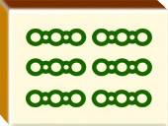
Bams of 456 can only be used once as Short Straight of Bams of 123 and 456, or Mixed Double Chow of Bams of 456 and Dots of 456.
Ex.2：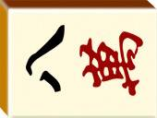 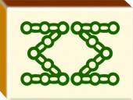
After identifying Mixed Triple Chow as Characters of 678, Bams of 678 and Dots of 678, another Bams of 678 can only be used once as Pure Double Chow of Bams of 678, or Mixed Double Chow of Characters of 678 or Dots of 678.
Ex.3：（Melded Kong） （Concealed Kong）
（Concealed Kong） 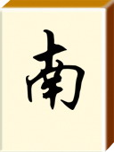
The primary fan is Three Kongs. Two Concealed Kongs, All Pungs, One Voided Suit and Self-Drawn can be added. Three Concealed Pungs can be added, as Characters of 777 combine swith Two Concealed Kongs.
Item 2 Definition of Fans
1、All Green
Half Flush can be added, because it has two expressions as Full Flush and Half Flush.
Seven Pairs can be added, but Tile Hog can not be.
2、Nine Gates
Concealed Hand can not be added. According to the definition, nine patterns from 1 to 9 must be waited, so Concealed Hand appears inevitably. Also Edge Wait, Closed Wait and Single Wait can not be added for nine patterns waited.
Pung of Terminals or Honors can not be added. Nine Gates include Pung of Terminals or Honors inevitably.
Fully Concealed Hand can be added.
P.S. Once Concealed Hand and Self-Drawn appear together, Fully Concealed Hand can be counted. So fans including Concealed Hand inevitably can count points of Fully Concealed Hand when Self-Drawn appears, such as Seven Shifted Pairs, Thirteen Orphans, Four Concealed Pungs, Seven Pairs, Greater Honors and Knitted Tiles, Lesser Honors and Knitted Tiles.
3、Four Kongs
There is a special explanation for the added points when Concealed Kong appears in Four Kongs.
Add 2 points of Concealed Kong when three Melded Kongs and one Concealed Kong appear.
Add 8 points of Two Concealed Kongs when two Melded Kongs and two Concealed Kongs appear.
Add 16 points of Three Concealed Pungs when one Melded Kongs and three Concealed Kongs appear.
Add 64 points of Four Concealed Pungs when four Concealed Kongs appear.
P.S. Add points when Concealed Kong appears in Three Kongs according to the above explanation.
4、All Terminals
Triple Pung and Double Pung can be added.
Seven Pairs can be added, so does it appearing in All Honors or All Terminals and Honors.
All Pungs and Pung of Terminals or Honors can not be added.
Tile Hog can not be added when Seven Pairs appears in All Terminals.
5、Four Pure Shifted Chows
Short Straight or Two Terminals Chows can not be added, as the two fans can not be added in Pure Straight.
6、All Even Pungs
It must be combined with Pungs, so Seven Pairs can not be added and vice versa.
7、Upper Tiles
Seven Pairs can be added, as the same as Middle Tiles, Lower Tiles, Upper Four and Lower Four.
8、Knitted Straight
It is a special Chow. Edge Wait and Closed Wait can not be added, and Chow is not allowed either.
9、Out with Replacement Tile
1 point can be added if Hu with Melded Kong, and 2 points if Concealed Kong. If Winning with the Flower replacement behind Konging, point of Self-Drawn can be added but Out With Replacement Tile can not.
10、Two Concealed Kongs has 8 points.
11、 One Melded Kongs and one Concealed Kongs has 6 points.
12、Edge Wait can only wait for one tile, as the same as Closed Wait and Single Wait
13、 Flower Tiles
Flower Tiles not replaced can be discarded, but those exposed and forgotten can not be. The player should take a replacement from the top to the bottom at the end of The Wall when Flower replacing and Konging.
Item 3 Responsibility for Referee
(1) Perform Fairly, Correctly and Politely
1、Referee should be qualified through special training, and execute the competition tasks seriously, fairly and correctly according to the related rules, regulation and laws.
2、Referee should study rules, improve skills, insist principles, exchange minds with each other and show a well performance.
3、Referee should perform politely and patiently, confer with related persons on the difficulties, keep distance from players and control the expression and words not to disturb the players.
(2) Familiar with Rules and Game Systems
1、There must be a minimum of six complete games in a regulation tournament. Each complete game adopt the Table Points system as 4, 2, 1, 0 from the highest to the lowest. Players are ranked based on the total Table Points during a regulation tournament, then on the total Contest Points if players have the same Table Points.
2、Each complete game is limited to 150 minutes, and 15 minutes is for rest time during the game session. Chief referee should announce finish time when there is a quarter left in a game session. The game session should be ended immediately when time is over, and the present scores are the final results.
3、Referee should check the tiles before one complete game. If there is something wrong with the tiles during the game, the players should change another suit of tiles instead, and the former scores are available.
4、Players should enter the contest hall and sit at the assigned table ahead of time, then referee check the player number and table number. Players should greet each other before the game, and thank each other for playing after the game. After the game, players and referee should sign on the scoring sheet to confirm the result.
5、Players dice and draw East, South, West and North Wind Tiles to fix the position before each game. Each round players should change positions according to a certain rule in Round Robin. The player who seated in East position should record the scores on the scoring sheet.
6、Referee should supervise players mixing the tiles and dicing correctly, and guide to fill in the scoring sheet.
7、If the dealer makes a wrong starting, the other players should point it out immediately. It is invalid to sue for the dealer`s wrong action after the game continues.
8、The dealer can replace all flower tiles in hand once. The dealer must discard the first tile within 20 seconds after Flower Replacement, and then all the players should discard a tile within 10 seconds after last player’s discarding. Pung must occur within 3 seconds after discarding.
9、Players are forbidden to talk or discuss with each other during a complete game.
Players should use normative terms, also can say “CHI”, “PENG”, “GANG”, “HUA” and “HU” for short.
10、Melded tiles should be shown in front of the hand tiles, such as Chow, Pung, Kong and Flower.
Player who is punished to continue playing without right to win (declare Mahjong or HU) still has the right to Chow, Pung and Kong.
11、Though somebody replaces other tiles as Flower Replacement wrongly (e.g. 1 Bam), the last tile can be made mahjong as Last Tile. The winning tile must be apart from the hand tiles to be examined.
12、After the last discarding and nobody can make mahjong, players can not Chow, Pung, or Kongs. No discarding is needed if the last drawn tile make a Kong.
13、There are five basic types of mahjong hand which is combined with a pair and Chows, Pungs, or Kongs, and three special types as Seven Pairs, Thirteen Orphans and Lesser/Greater Honors and Knitted Tiles.
14、Concealed pungs should be shown after somebody’s winning has been confirmed. Or the shown pung tiles should be treated as exposed tiles.
15、After winning the player should count the points himself, then the other players check it, finally the referee auditing it if there is some trouble. Once the points have been recorded, players can not express objections. Referee can not suggest players how to count the points.
16、If it has to change a certain player during the match, only one player’s best result of the related players can be counted for ranking.
Item 4 Fouls and Penalties
1、Being late should be docked 10 Contest points within ten minutes, and 20 Contest points within fifteen minutes. The player being late for more than 15 fifteen minutes is deemed to disclaim the certain game session and get 0 Table points.
2、Specific violations and relevant penalties should depend on the real degree and accord with the criteria of the rules.
1) Referee has the right to penalize the player and stop his match when a player replaces a concealed standing tile by stealth or hides a tile, or otherwise cheats.
2) When a player has erred in making chow, pung, kong, or flower replacement, the player will forfeit the right to declare mahjong (to win) during the current hand.
3) Players can not call a tile for exposure and then decide not to take the tile. This "change of heart" is known as making an "empty" call. The player will be warned the first time he makes an empty Chow, Pung, or Kong, then the second time he'll forfeit 5 points, third time 10 points; fourth time 20 points, and so on.
4) Declaring Pung out of 3 seconds after the last discarding is a foul. In one round, the player will be warned for the first time, then he will forfeit 5 points for the second time, 10 points for the third time, 20 points for the forth time, and so on.
5) For the wrongly drawn, if the tile is not put into hand, the player should replace it to original position, or the player will forfeit the right to declare mahjong (to win) during the current hand.
6) If a player makes a False Hu (or False Mahjong) and the hand keeps Waiting,, he will forfeit the right to declare mahjong (to win) during the current hand and 10 points to each of the other three players.
If a player makes a False Hu (or False Mahjong) and the hand does not keep Waiting, he will forfeit the right to declare mahjong (to win) during the current hand and 20 points to each of the other three players.
7) An exposed tile should be discarded on the player's next turn. If there is a special rule or caused by the device of mahjong, play as the special rule.
If a player exposes all his tiles after somebody declares Hu, he makes a foul. If it is confirmed that the declarer indeed wins, the player showing his tiles will get a warning; if the declarer's hand is confirmed to be invalid, the player who exposed his tiles will forfeit his right to declare mahjong (to win) during the current hand, and discard all the shown tiles one by one. If a player breaks the hand tiles or Walls and causes the current hand can not be continued, he will forfeit 30 points to each of the other three players after the referee’s confirmation.
A player who knocks over another player’s tile will forfeit 5~60 points to the suffered player under the referee’s confirmation. And the referee should decide whether the current hand continues.
If a player`s declaring Hu is invalid, the shown tiles are not treated as exposed tiles.
Item 5 Other Rules
1、After declaring "Chi," "Pung," or "Kong", the called-for discarded tile should be taken back within a reasonable time. If not taken in 2 turns (before the second drawn), the player has to continue playing, with no right to declare mahjong until the end of the current hand.
2、After declaring "Hu," the called-for discarded tile should be taken back before counting points. Or it will be treated as False Hu.
3、If a player declares “CHI”, “PENG”, and “GANG” first and then change to declare “HU”, or he express his declaration of HU in nonstandard ways, all those are foul. If his hand tiles are not exposed, he can not win during the present go-around and can win after next drawn. If all his hand tiles are exposed, he will forfeit the right to win, and must continue playing until the end of the current hand.
4、If a player shows all the hand tiles first and then declares Hu, he will forfeit right to declare mahjong (to win) during the current hand.
5、If a player stretches out his hand across the discard Floor and intends to drawn a fresh tile from the Wall, that means he has given up the right to take the present discard, so he can not chow, pung, and kong and win during the present go-round.
6、After declaring "Hu", the player should use discarded tiles from the discard Floor to count the points. Each face-up tile represents 1 point; one face-down tile represents 10 points. If tiles from the player's hand and other discarded tiles are mixed to count the points, it is a foul. After the referee verifies the foul, the player's win is declared invalid; the current hand continues but the player can not win it.
7、Principle for Referee Performing
Perform fairly and correctly;
Perform peacefully: should be good-tempered;
Should be tolerant and friendly;
Hu should be the first ;
Penalties should depend on the real degree of actions, voluntary or involuntary actions;
No-Objection after recorded.
8、Introduction of Table Design
(1) Turnup Design
Game 1: The numbers of players are divided into four groups equally and orderly.
Ex. Game 1
Group 1: 1 2 3 4 5 6 7 8 9 10 11 12
Group 2: 13 14 15 16 17 18 19 20 21 22 23 24
Group3: 25 26 27 28 29 30 31 32 33 34 35 36
Group4: 37 38 39 40 41 42 43 44 45 46 47 48
Game 2: Players change tables regularly.
Plan 1: Group 1 hold position, then Group 2 move rightward for one position, then Group 3 rightward for two, then Group 4 rightward for three.
Plan 2: Group 1 move leftward for one position, then Group 2 move rightward for one, then Group 3 rightward for two, then Group 4 rightward for three.
Plan 3: Group 1 move leftward for one position, then Group 2 move rightward for one, then Group 3 leftward for two, then Group 4 rightward for two.
Ex. Game2 Plan 3
Group1: 2 3 4 5 6 7 8 9 10 11 12 1
Group 2: 24 13 14 15 16 17 18 19 20 21 22 23
Group3: 27 28 29 30 31 32 33 34 35 36 25 26
Group4: 47 48 37 38 39 40 41 42 43 44 45 46
Game 3: Players change tables as above.
If there are many players, players can move for more steps.
(2) Jump Design
The numbers of players are ranged as a line, then sort out them as certain space like jumping and rearrange each four in one table.
Ex. 1 2 3 4 5 6 7 8 9 10 11 12 13 14 15 16 1 7……..
Then 1 5 9 13 in table 1, 2 6 10 14 in table 2, 3 7 11 15 in table 3, 4 8 12 16 in table 4 etc.
(3) Turnup-Jump Design
Use Turnup Design and Jump Design by turns. For example, Game 1 and 2 use Turnup Design, then Game 3 use Jump Design, then Game 4 and 5 Turnup Design, then Game 6 Jump Design,
9、High to High (Source from Swiss Movement in Bridge)
（1）Game 1 should be designed as the above method, then from Game 2 players are redesigned as the former total results every game, as high result to high result, low to low. It is mainly used for Single Match.
（2）The earlier games are designed as the above method, then the latter games as High to High. It can be used for Single or Team Event.

The above introduction is mainly about the explanation of Mahjong Competition Rules. Though different understandings still remain, we sincerely welcome every Mahjong Game lover to exchange mind and discuss with each other, then we get the same understanding.

